Lucrare de laborator Nr.6 (Varianta VIII)

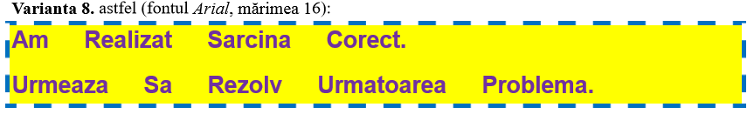

**<!DOCTYPE html>**

**<html>**

**<head>**

**<style>**

**p.labor2{**

**display: block;**

**background-color: yellow;**

**color:#7030a0;**

**outline-style:dashed;**

**outline-color: #0070c0;**

**outline-width: thick ;**

**word-spacing: 1em;**

**font-size:16;**

**font-family: Arial;**

**text-transform: capitalize;**

**font-weight: bold;**

**line-height: 1.8;**

**}**

**</style>**

**</head>**

**<body>**

**<p class="labor2">**

**Am realizat sarcina corect. <br>**

**Urmeaza sa rezolv urmatoarea problema.**

**</p>**

**</body>**

**</html>**

